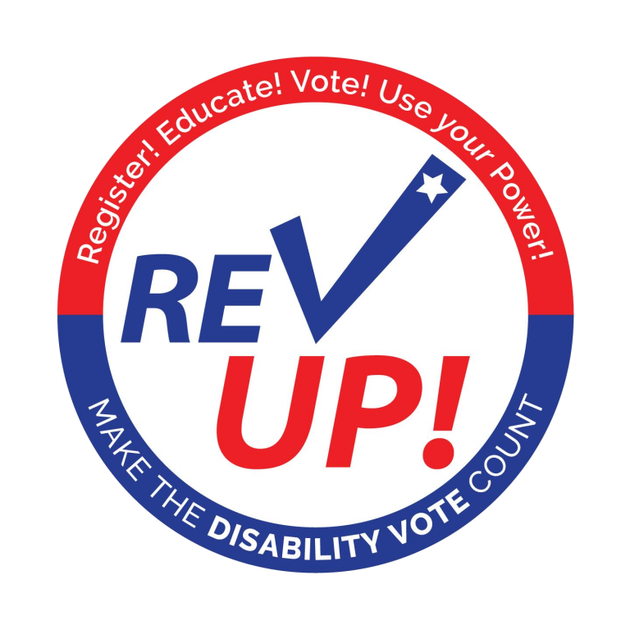
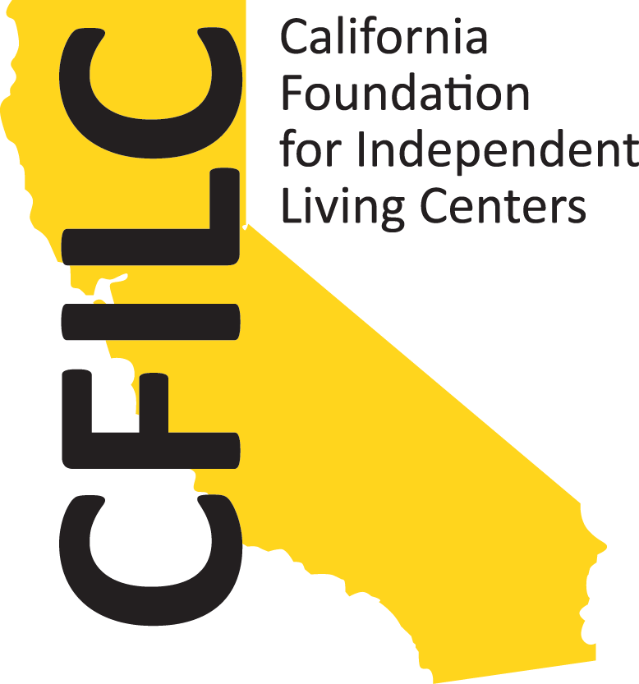
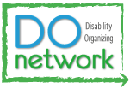

Celebrate National Disability Voter Registration Week 2019 with California’s Disability Organizing Network!

Partner Resource Guide:

Key Dates 1
Social Media Resources 2
What Is A Spotlight? 2
Tips on Social Media Accessibility and Online Organizing: 3
In-Person Events and Activities 4
Best Practices For Voter Registration Drives: 5
Other Recommended Voting Resources 7
National Resources 7
California Resources 7
Resources on Hosting Accessible Events* 8
Credits 8

Key Dates

- From June 25th-July 3rd, for questions or concerns:
  - For social media: Kyla Aquino-Irving at kyla@cfilc.org
  - For in person events: Elizabeth Campbell at ecampbell@daylemc.org
- July 12th: Deadline to complete the Disability Organizing Network Partner Join Form
- July 8th-12th: One-on-one support available, Allie Cannington at allie@cfilc.org and text/call 916.606.5300.
- July 9th from 1-2PM: Partner Support Session
  - Join via Zoom: https://zoom.us/j/348561664
  - Or call in: +1 408 638 0968; Meeting ID: 348 561 664

July 15th-19th, 2019: National Voter Registration Week #DisabilityVoteCA

Social Media Resources

What Is A Spotlight?
- National Voter Registration Week gives partners an opportunity to highlight leaders, shout-out notable community members, and organizations on social media.
- The best spotlights have a photo/image and text.The text can be 1-3 sentences, it can be a quote from the leader or a description of why you are spotlighting them.
- Ideas for who or what to spotlight:
  - Your local elections official or registrar
  - Your local Voting Accessibility Advisory Committee (VAAC)
  - A member of your local VAAC
  - Your city council member or supervisor
  - A local, regional, or statewide voting rights advocate

- Examples of spotlight posts:

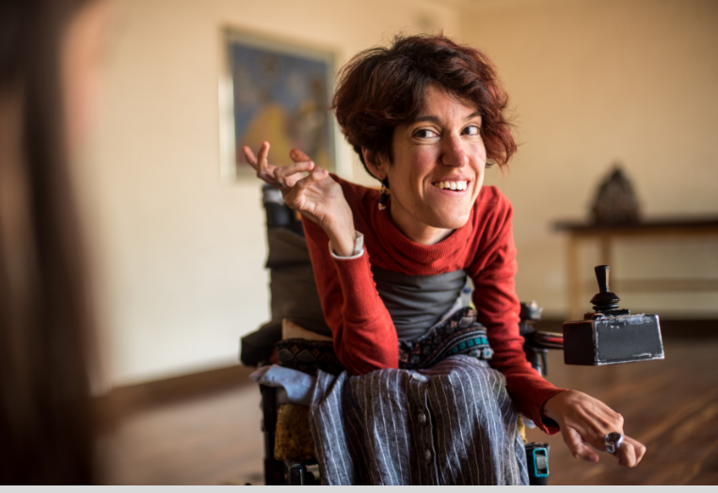
Be sure to put alt text or an image description. The image description of these mock spotlights are in the alt text. (Click here to learn more about image descriptions)

Mock Spotlight #1:
“For National Disability Voter Registration Week, we are excited to spotlight Brenda Snow, who serves as chair of the Wonderland, CA VAAC! She is a leader in Disability voter access in our community! #DisabilityVoteCA”

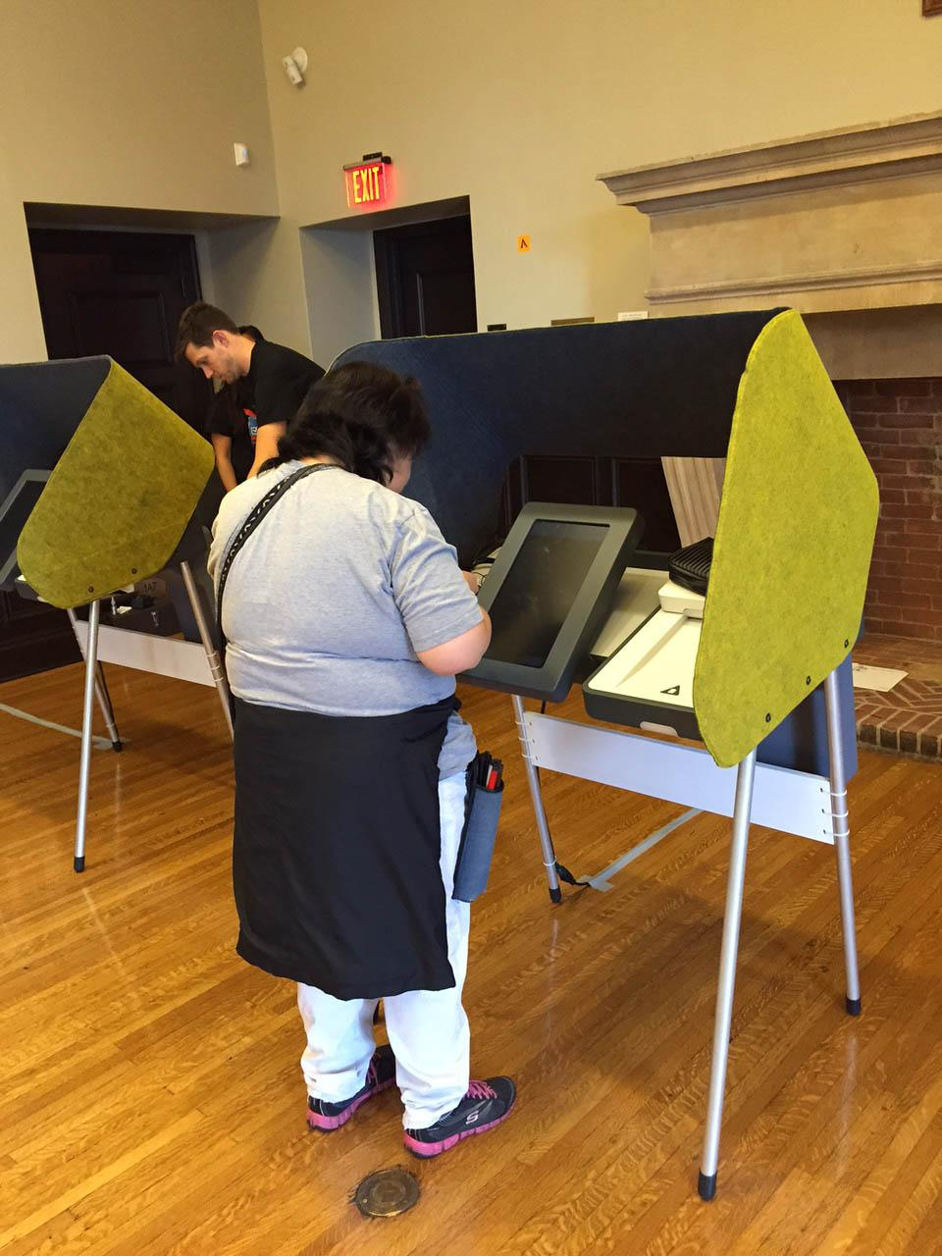
Image description: Young white female adult smiling with a short red hair waving from her wheelchair.
Mock Spotlight #2: “‘We do not have government by the majority. We have government by the majority who participate.’- Thomas Jefferson. The elections office in Wonderland, CA is making sure that the Disability community is participating in the next Election by installing accessible voting machines. #DisabilityVoteCA”

Image description: people at accessible voting booths.

Tips on Social Media Accessibility and Online Organizing:
- The Revolution Will Be Tweeted: Basics of Mobilizing For Social Media - Learn the basics of major social media platforms and how to use them for community organizing campaigns. Learn tactics for reaching and engaging your intended audience and ensuring accessible content.

- The Power of Disability Stories - Learn from Alice Wong of the Disability Visibility Project about the elements of a good story, different formats for stories, and how to create them

- 9 Best Practices from Mia Ives-Rublee And Alyssa Klein

In-Person Events and Activities
Note: the amount of time, planning, and labor for each below activity ranges. We encourage you to modify or combine ideas!

- Run a Voter Registration Drive (See next section for details.)
- Host a community meeting. Invite people with disabilities, seniors, and/or allies to engage in dialogue about the barriers and opportunities of voting
  - Provide a workshop or training on the voting rights of people with disabilities Disability Rights California can be a great partner. Consider these topics for the training:
    - Why is it important to vote?
    - How and when do you need to register to vote
    - How to become an informed voter
    - Ways to vote in California
    - Voters’ rights at the polls
  - Host a workshop or training on your state’s voting laws and process and your local elections office can be a great partner Host a Voter Pledge Drive/Party
  - Organize a town hall event or individual meetings with candidates before upcoming Elections so they can meet and hear from people with disabilities in your community. As a nonpartisan 501(c)(3) nonprofit organization you must send an invitation to all candidates. Nonprofit VOTE offers additional resources and guides on staying nonpartisan
  - Schedule an accessible voting machine user testing session or demonstration with your local elections office. Check out Voting Machine Accessibility Resources & Checklists.
- Gather a group to pledge to vote on Election Day! Any voter pledge activity can be combined into a staff meeting, pre-existing event, OR you can make it specific:
  - Drive - Tabling event at an already existing event or high trafficked area
  - Party - Higher energy gathering or kick back, and gather in a relaxed setting, like your backyard or community center and incorporate the pledges during the event
- Partner with your local public library and through the EveryLibrary program Libraries are often hubs for marginalized communities gather
- Make your organization a polling place (Resources: How To Serve As A Polling Site and ADA Polling Place Checklist)
- Connect with your Governor, Mayor, City Council, County Commissioner, State Representative, etc. to issue a proclamation declaring National Disability Voter Registration Week (a draft Proclamation is available here)
- Hold a press event or conference with local partners to announce national and local efforts to get new people with disabilities registered to vote, educated on disability issues, and committed to get out the DISABILITY VOTE. If possible, coordinate multiple sites around your state to host press events at the same time. Download a press release template here (2018)
- Write letters to the editor or Op-Eds and engage local radio orTV stations on the growing efforts and power of the disability community
- Organize a rally of voters and advocates with disabilities to promote the REVUP message and the power of the DISABILITY VOTE!

Best Practices For Voter Registration Drives

Before the Drive

For National Voter Registration Act (NVRA)/SB35 Agencies, which include all California Independent Living Centers, review the 2019 CA NVRA Manual

STEP 1 (recommended 3-6 weeks before):
Contact your local elections office about training everyone involved in your registration drive. Please refer to the Secretary of State’s website for a list of local elections offices and Voter Registration Frequently Asked Questions resource

STEP 2 (recommended 3-4 weeks before):
Pick a date, time, and location between July 15th-19th, 2019

- Aim for spaces where people will already be, like a local farmers market or county faire
- Check community calendars to be sure your event doesn't conflict with other significant community events
- Define your target population (who do you need to reach?)
- Consider partnering with a local supportive housing program, low income housing, shelters, etc. if you participate in door-to-door canvassing
- Focus on communities with a history of low turnout and registration rates
- Get permission to host the drive, if needed
- Make a list of all access and functional needs

STEP 3 (recommended 2-3 weeks before):
Promote Event

- Begin publicizing the activity through snail mail, email, and social media networks using #DisabilityVoteCA (Feel free to use materials from the Disability Organizing Network)
- Reach out to other organizations in the community and ask them to help promote the event
- Recruit and train volunteers, if needed
- Reach out to friends, colleagues, or family and encourage them to share your event with their networks
- Ensure all volunteers know their assigned roles
- Mark your calendars for the online Partner Support Session July 9th from 1-2PM

STEP 4 (recommended 1 week before):
Gather supplies you may need

- Tables and chairs
- Smartphones, tablets, laptops (Do you have access to WiFi or do you have a HotSpot?)
- Office supplies: Clipboards, sticky notes, tape, black and blue pens
- Sign-in sheet to track the people you register, don’t forget to have them share their city/town and zip code for future voter outreach efforts (paper or electronic)
- Pledge forms for registered voters (see below for examples)
- Posters, banners, and signs that say "Register to Vote Here"
- List of upcoming Election dates and deadlines
- List of polling places or Vote Centers in your community
- Snacks for staff and volunteers (water bottles, granola bars, etc.)

During the Drive

- Have all supplies ready
- Be ready to document the drive on social media using #DisabilityVoteCA
- If possible, get out from behind the table when interacting with people
- Non-registered voters will rarely self-identify – instead say “Are you a registered voter?” ask “Do you need to register or UPDATE your registration?”
- Remain nonpartisan – make sure no one is denied registration or treated differently because of party affiliation
- Manage Expectations: Don’t be discouraged if you do not have people approaching your table, be kind and professional

After the Drive

- Promptly turn in the registration forms to your local elections office for processing
- Evaluate the success of your drive
  - Did you select a good date and time?
  - Was your location successful (high-traffic, visible to passersby, etc.)?
  - Did your table attract attention?
  - Did you have enough volunteers?
  - Did you target the right population?
- Tally and report your voter registration and voter pledge numbers
- Share this information with event partners
- Share this data with the national REVUP Campaign and Disability Organizing Network by completing NDVRW Reporting Form. We want to track out impact, having concrete voter registration and engagement numbers helps us demonstrate the power of the Disability community!

Other Recommended Voting Resources

National Resources
- SABE GoVoter Project - Voter Education Toolkit and more
- American Association of People with Disabilities (AAPD) - REVUP and more
- Bazelon Center for Mental Health Law
- Nonprofit VOTE: Voter Registration Resource Library has many resources relating to voter engagement.
  - A Voter Registration Toolkit
  - Seven Reasons for a Nonprofit to Do Voter Registration
  - A Voter Registration Checklist
  - Voter Registration Training Video
  - Sample Script for Voter Registration
- United Way: Voter Engagement Toolkit offers a comprehensive voter engagement toolkit that includes a guide for planning and conducting a voter registration event,education,connecting with candidates, ballot measures, utilizing social media, and more
- www.SignVote.org - For the Deaf & Hard of Hearing communities

California Resources
- CA Secretary of State - Voters with Disabilities
- Disability Rights California
  - Voting Rights Resources
  - Voting Videos (including Vote Centers and Remote Accessible Vote by Mail)
- Disability Organizing Network - Voting Resources and past Archived Webinars
- Disability Vote California
- League of Women Voters CA Education Fund

Resources on Hosting Accessible Events*

- Access Suggestions for a Public Event, Sins Invalid, January 24, 2017
- “How to Make Your Social Justice Events Accessible to the Disability Community: A Checklist,” s.e. smith, Rooted in Rights, February 3, 2017.
- A Guide to Planning Inclusive Events, Seminars, and Activities, Alex Umstead and Diane Wiener, Disability Cultural Center, Syracuse University, February 2015
- A Planning Guide for Making Temporary Events Accessible to People with Disabilities, ADA National Network, 2015
- Disability and Access Toolkit, Showing Up for Racial Justice
- “Planning Accessible and Inclusive Organizing Trainings: Strategies for Decreasing Barriers to Participation for People with I/DD,” Autistic Self Advocacy Network.
- Accessibility Is for Everyone: How to Rock your ASA Presentation and Make it Inclusive, Angela Frederick and Laura Mauldin, ASA Footnotes, Jan-Mar 2019, Vol 47, Issue 1
- Scent and Fragrance free
  - East Bay Meditation Center resources
  - Leah Lakshmi Piepzna-Samarasinha

Credits

- Adapted from American Association of People with Disabilities, REVUP National Disability Voter Registration Week content and resources
- *Resources for Accessible Events were found on Access is Love reading list from Alice Wong, Sandy Ho, & Mia Mingus of the #AccessIsLove project
- Gratitude and credit to the first official use of #DisabilityVoteCA during the 2018 launch of www.disabilityvoteca.org from The Arc of California, California State Council on Developmental Disabilities, and Disability Rights California
# # #

