Social Media Guide

California’s National Disability Voter Registration Week (NDVRW)

#DisabilityVoteCA

Helpful Tips
- Use the right hashtags. Include relevant hashtags like #DisabilityVoteCA, and #REVUP and in all your social media posts for greater visibility

- Use photos. Tweets with photos perform five times better than those without, and good photos are priceless on Facebook. Bring your phone and snap photos from a voter registration event or any in person gathering you are participating in . Be sure to send us your photos so that we can help celebrate your efforts. E-mail us at socialmedia@cfilc.org.

- Tag @donetworkorg We want to help share your messages! Tag DOnetwork’s social media handles in all your posts so that we can share your content and recognize your hard work. Make sure to follow DOnetwork on the following social media outlets:
  - Facebook: Disability Organizing (DO) Network
  - Twitter: @donetworkorg
  - Instagram: @donetworkorg

- Learn more. Get more tips on best practices and accessibility from our social media 101 guide: The Revolution Will Be Tweeted.

Keep Us In The Loop!
Be sure to let the Disability Organizing Network know about your activities so we can capture the breadth of the disability voting bloc and also help promote your event and resources. Please sign up as a partner or contact us at socialmedia@cfilc.org

Graphics
Profile Photo Frame:

Change your social media profile photo to include #DisabilityVoteCA: Twitter | Facebook.

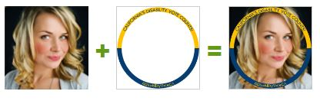
Image description: Series of 3 photos. Closeup photo of a young, white woman with blonde hair smiling slightly. Plus sign. Image of a yellow and blue circle with text. Equals sign. Image of the original photo with the yellow and blue circle on top.

#DisabilityVoteCA images are also available through the Disability Organizing Network (DOnetwork) website (http://disabilityorganizing.net/news-topics/?id=710). All images include image descriptions and are free for you to use and customize.

Ideal Twitter, Facebook, or LinkedIn graphic size for posts (1024 x 512px) :
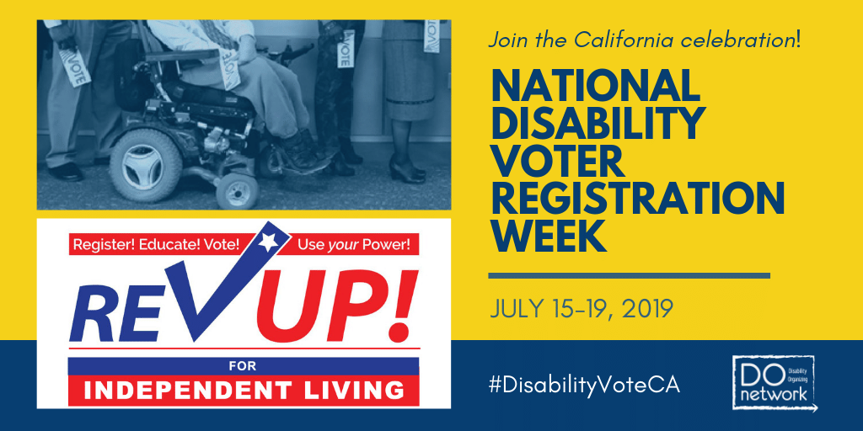

Image description: Photo of people standing in line holding small cards that read, “VOTE”. One man in a suit is in a power wheelchair. Text: “Join the California celebration! NATIONAL DISABILITY VOTER REGISTRATION WEEK. JULY 15-19, 2019. Register! Educate! Vote! Use your Power! REVUP! For Independent Living. #DisabilityVoteCA. Disability Organizing logo.
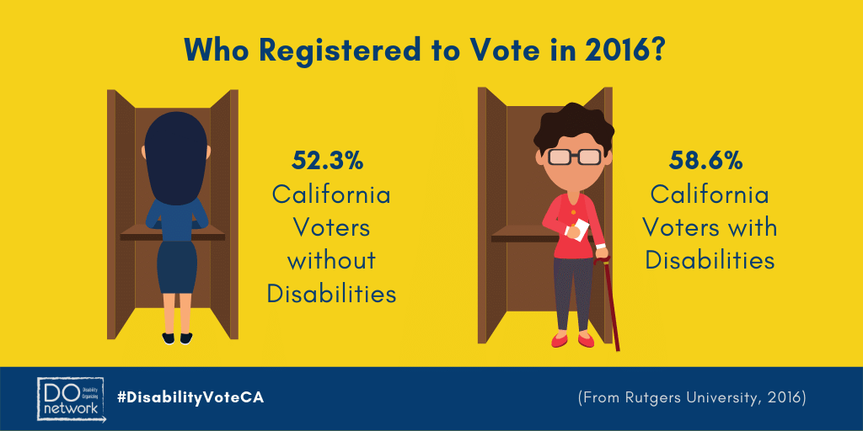

Image description: Title text: Who Registered to Vote in 2016? Woman wearing blue shirt and skirt standing at the voting booth. Text: 52.3% California Voters without Disabilities. Short-haired person at the voting booth wearing glasses and holding a ballot in one hand and a brown cane in the other. Text: 58.6% California Voters with Disabilities.

Ideal size for Instagram post (square):
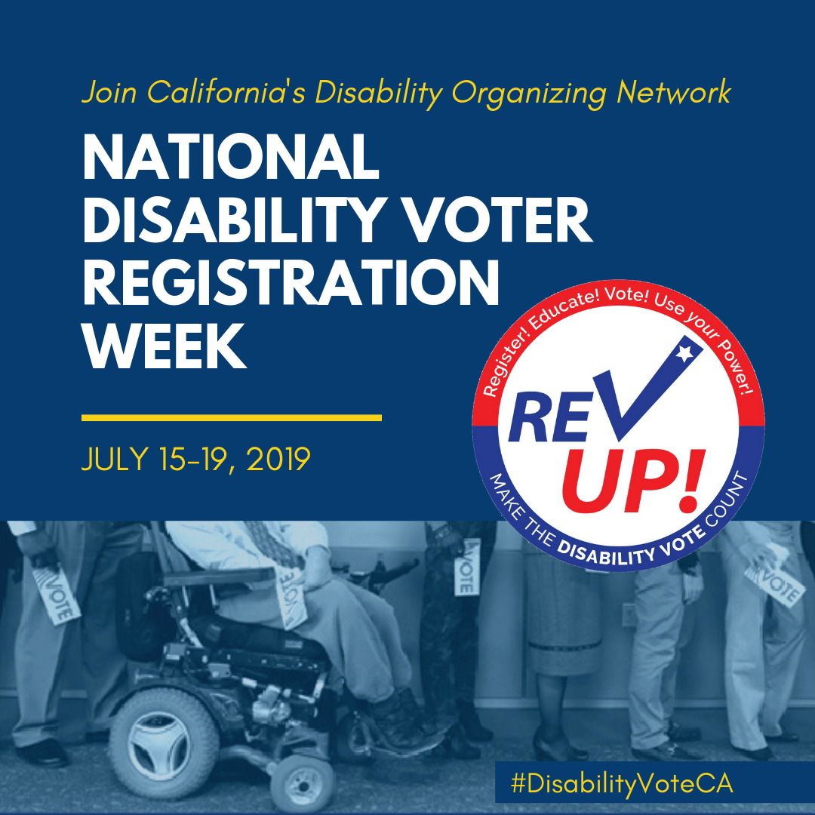
Image description: a photo of people standing in line holding small cards that read “VOTE”. One man in a suit is in a power wheelchair. Text: “Join California’s celebration! NATIONAL DISABILITY VOTER REGISTRATION WEEK. JULY 15-19, 2019. Register! Educate! Vote! Use your Power! REVUP! For Independent Living. #DisabilityVoteCA.

Facebook cover (820 x 312):

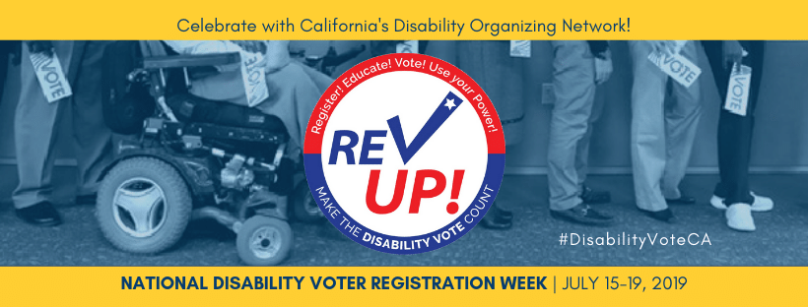
Image description: a photo of people standing in line holding small cards that read “VOTE”. One man in a suit is in a power wheelchair. Text: “Celebrate with California’s Disability Organizing Network! Register! Educate! Vote! Use your Power! REVUP! Make the Disability Vote Count. #DisabilityVoteCA. NATIONAL DISABILITY VOTER REGISTRATION WEEK. JULY 15-19, 2019.

National NDVRW Campaign

REV UP logos and images are available on the AAPD website (https://www.dropbox.com/sh/4y3qs92r80ajv23/AABfeAabZ6xBgxrzX472Wj7Ba?dl=0) and are also free for your use and customization.

Sample Messages
(Please edit, adapt, and customize as you see fit!)

Facebook/Instagram/Twitter:

Your vote is your voice! Time to #REVUP and make the DISABILITY VOTE count! http://disabilityorganizing.net/news-topics/?id=710 #DisabilityVoteCA

Excited to be a partner with @DOnetwork to show power of #DisabilityVoteCA & celebrate #REVUP National Disability Voter Registration Week – Join us! http://disabilityorganizing.net/news-topics/?id=710

Have you registered to vote? Do you need to re-register? Now is the time! http://registertovote.ca.gov/?t=vra&id=134 It only takes 2 minutes! #DisabilityVoteCA #REVUP

"VOTE as if your life depends on it—Because it DOES!" - Justin Dart #REVUP #DisabilityVoteCA #GOTV www.aapd.com/REVUP

Declare July 15-19 as National Disability Voter Registration Week in your state, county, or city. #REVUP #DisabilityVoteCA
http://disabilityorganizing.net/news-topics/?id=710

Check out the REV UP Voter Resource Center for information on registering to vote, policies impacting voters with disabilities, candidates and issues in the current election, and how you can be a catalyst to make the DISABILITY VOTE count! #REVUP #DisabilityVoteCA
http://www.aapd.com/our-focus/voting/voter-resource-center/

Learn how to make your organization a polling place for people with disabilities. #REVUP #DisabilityVoteCA #GOTV
http://www.aapd.com/our-focus/voting/national-disability-voter-registration-week/

“We do not have government by the majority. We have government by the majority who participate.” - Thomas Jefferson. We must participate, California! Register here: http://registertovote.ca.gov/?t=vra&id=134 #REVUP #DisabilityVoteCA #GOTV

Sample Spotlights
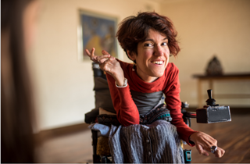
Sample Individual Spotlight:
For National Disability Voter Registration Week, we are excited to spotlight Brenda Snow, who serves as chair of the Wonderland, CA VAAC! She is a leader in Disability voter access in our community! #DisabilityVoteCA

Image description: Young white female adult smiling with a short red hair waving from her wheelchair.
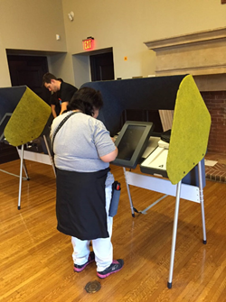
Sample Location Spotlight:
The elections office in Wonderland, CA is making sure that the Disability community is participating in the 2020 Elections by installing accessible voting machines. #DisabilityVoteCA”

Image description: people at accessible voting booths.

