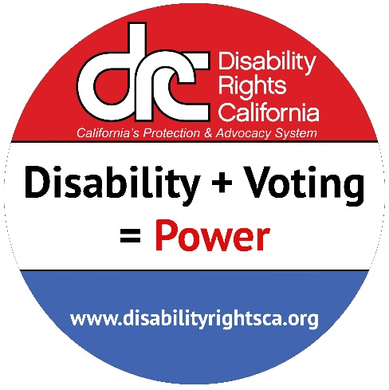
Tuesday
June 7th, 2016
Election Day Hotline
If you have a disability and
- You cannot get into your polling place
- The accessible voting machine is not working
- Other people can see how you are voting
- You are told you cannot vote because you have a disability
- You have a question about you right to vote
Disability Rights California can:
- Explain your rights
- Work to resolve the problem
- Help you file a complaint
Voice - 1-888-569-7955
TTY - 1-800-719-5798
If you need to call through relay, you can contact the California relay service by dialing 711.
For assistance in a language other than English, you may be put on hold while we connect with interpreters.
www.disabilityrightsca.org

