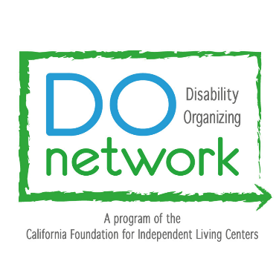
[Insert Date]
The Honorable [Insert Representative]
California [Insert whether Senate or Assembly]
State Capitol
Sacramento, CA 95814

Dear [Senator or Assembly Member] [Insert Senator/Assembly Member’s Last Name],
I hope this letter finds you well. My name is [Insert your name], and I am the [Insert your job position] for the [Insert Your Center]. I am looking forward to working with you on behalf of our constituency, people with disabilities in [Insert Your County], to create more equitable and accessible spaces.
The [Insert Your Center], also referred to as [Insert Center’s Acronym], is a 501(c)(3) nonprofit organization that provides services to community members with disabilities and facilitates equal access and inclusion within the community. The [Insert Your Center] partners with individuals with disabilities in surrounding areas to address current concerns and achieve personal goals toward maximum independence. We provide aid without bias for age, race, gender, income, or type of disability. The [Insert Your Center] is a peer-based organization. This means that most of the staff is comprised of individuals who have disabilities themselves and have met the challenges, barriers, and obstacles of becoming independently self-sufficient.
As Systems Change Advocate for [Insert Your Center], I work to identify systemic barriers that individuals with disabilities in [Insert Your County] face and then attempt to remove these barriers by advocating for change on the government level to meet the needs of the community. I am one voice of many for the needs of the disability community in [Insert Your County].
As such, we would also like to learn more about your visions for the upcoming session, and any areas with which I can assist your team. I look forward to connecting with you. Thank you for your time and consideration.

Sincerely,
[Insert your First and Last Name]
[Insert your Center]

